Barron County

Bicycle & Pedestrian Plan

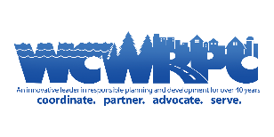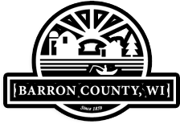

What is it?

A plan that will identify opportunities to add and improve bicycle and pedestrian infrastructure in Barron County.

What are the benefits?

Having an adopted plan will allow Barron County to achieve several goals as road improvement projects are undertaken in the coming years. These benefits include:

1. Potential grant funding to help pay for road improvements that incorporate bicycle and pedestrian infrastructure.
2. A more accessible network giving residents and visitors more transportation options throughout the County.
3. Increased tourism and economic development opportunities as the County becomes more interconnected with regional, state, and national trail systems.

How can people participate?

Public participation is essential to this plan. Throughout the project, Barron County will host various opportunities for public input. A survey and mapping exercises will be available on the project website. Additionally, the first of two Public Open Houses is being hosted at the Barron County Highway Department Crew Room on Tuesday, October 24th from 5 to 7 PM.

For more information, visit:

barron-county-bike-and-pedestrian-plan-wcwrpc.hub.arcgis.com